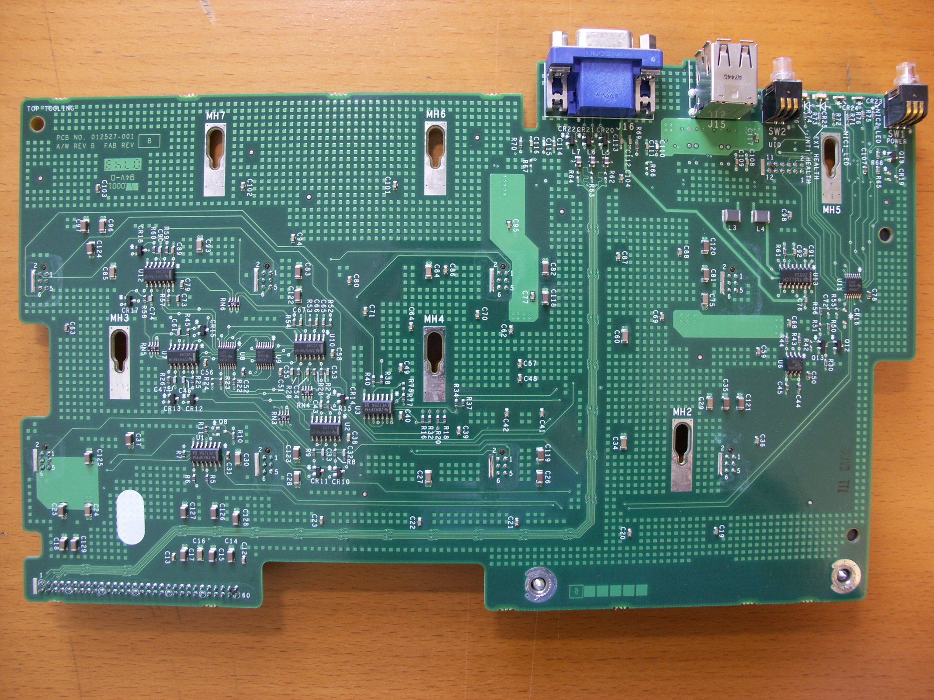

FAN PINS ON PCB

1. FAN SENSE SIGNAL (TO LVC14A)

FAN6 JUMPER TO GND = REDUNDANCY OFF

1. FAN PRESENCE

OPEN = ABSENT

GND = PRESENT

1. +12V
2. GND
3. FAN PWM SIGNAL (FROM LVC125A)
4. NC

FAN LEAD COLORS

1. YELLOW
2. BLACK
3. RED
4. BLACK
5. GREEN
6. NC